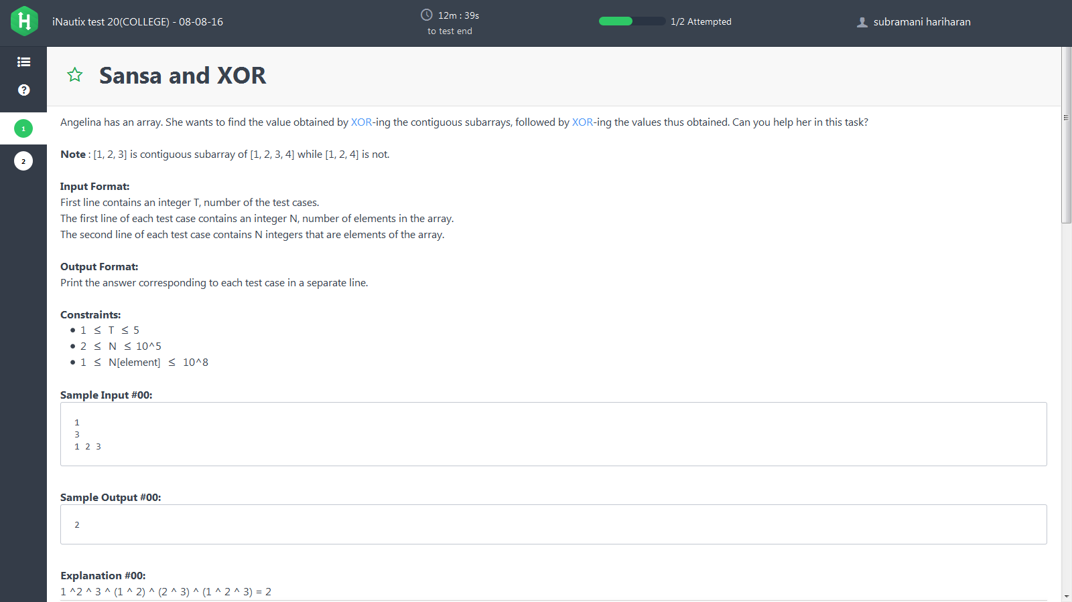

Solution:

#include <stdio.h>

#include <string.h>

#include <math.h>

#include <stdlib.h>

int main() {

/* Enter your code here. Read input from STDIN. Print output to STDOUT */

int t;

scanf("%d",&t);

while(t--)

{

long int n,*a;

scanf("%ld",&n);

a=(long int*)malloc((n+1)*sizeof(long int));

int i,xor=0;

for(i=1;i<=n;i++)

{

scanf("%ld",&a[i]);

}

if(n%2==0)

{

printf("0\n");

}

else

{

for(i=1;i<=n;i++)

{

if(i%2!=0)

{

xor=xor ^ a[i];

}

}

printf("%d\n",xor);

}

}

return 0;

}

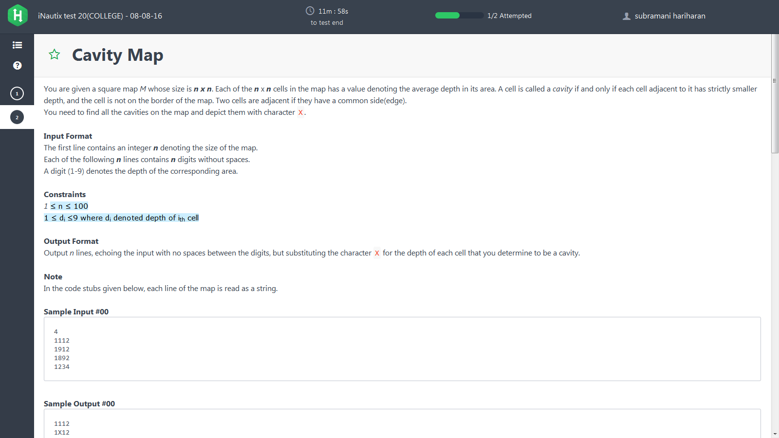

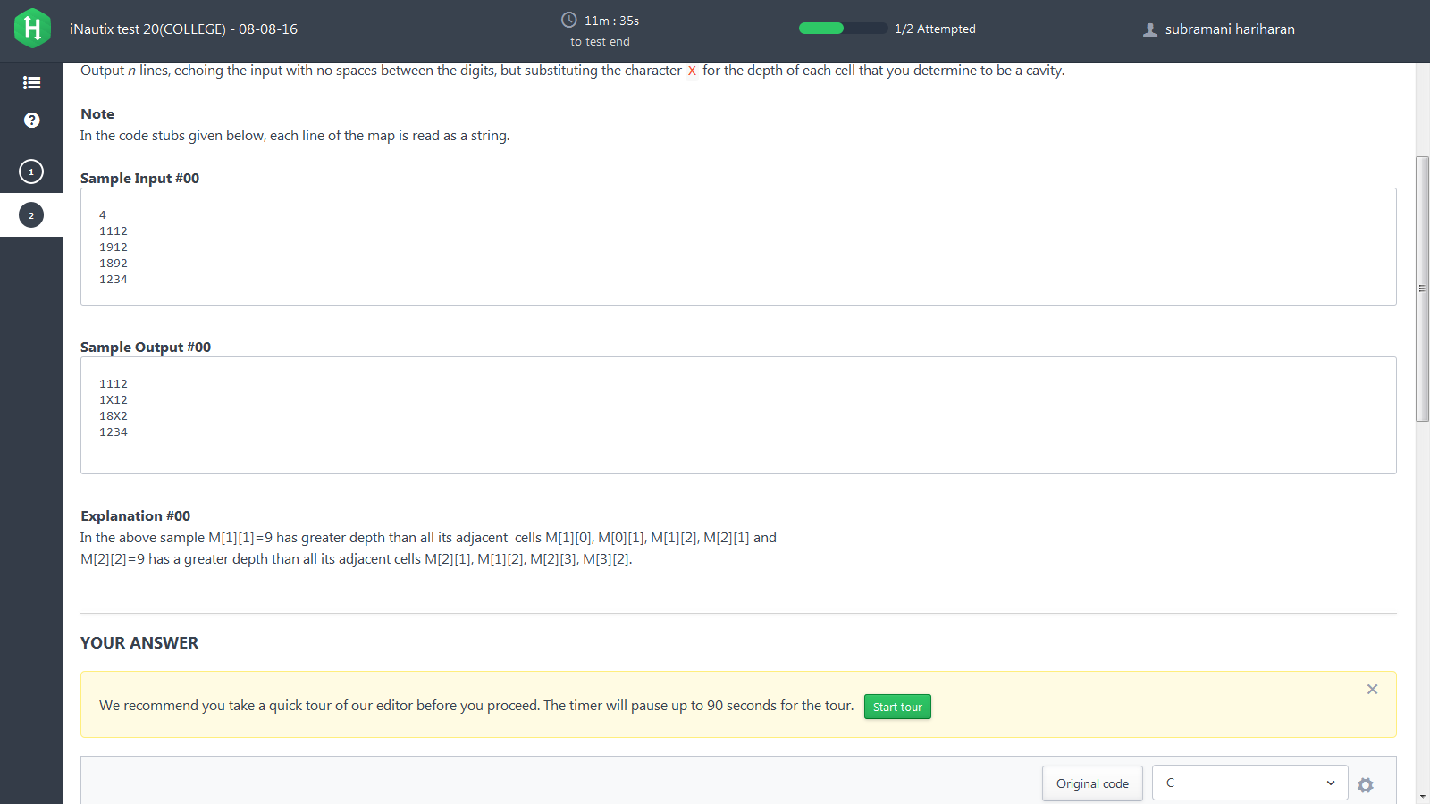

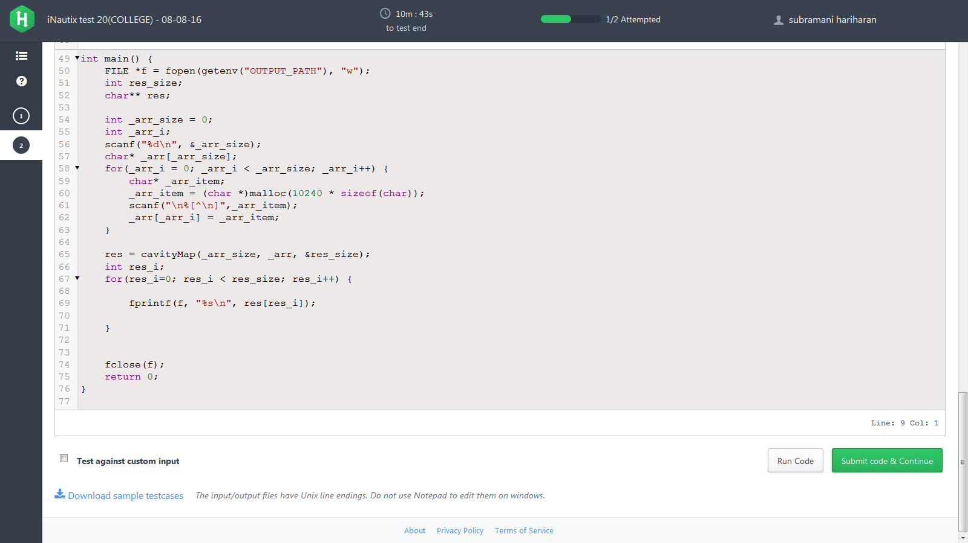

/*

* Complete the function below.

*/

char** cavityMap(int arr_size, char** arr, int* result_size) {

*result_size = arr_size;

char **result;

int i,j;

result=(char **)malloc(arr_size * sizeof(char *));

for(i=0;i<arr_size;i++)

{

result[i]=(char *)malloc(100*sizeof(char));

for(j=0;j<arr_size;j++)

{

result[i][j]=arr[i][j]; //taking a copy of given array

}

}

int n=arr_size-1;

for(i=1;i<n;i++)

{

for(j=1;j<n;j++)

{

int val=arr[i][j];

if((val>arr[i-1][j])&&(val>arr[i+1][j])&&(val>arr[i][j-1])&&(val>arr[i][j+1]))

result[i][j]='X';

}

}

return result;

}